Any Kitchen

Recipe Book

White Goods

Shopping List

Wishlist

Calendar

Recipe Maker

White Good Provider

Banana Bread

Pancakes

Carrot Cake

Gnocchi

Design 1

Banana Bread

Ingredients:

-Eggs (4)

-Flour (250g)

-Sugar (100g)

-Bananas (4)

-Cinnamon

Method:

1. Combine all dry ingredients including flour, sugar and cinnamon
2. Mash the bananas into a fine paste

Any Kitchen

Recipe Book

White Goods

Shopping List

Wishlist

Calendar

Recipe Maker

White Good Provider

Any Kitchen

Recipe Book

White Goods

Shopping List

Wishlist

Calendar

Recipe Maker

White Good Provider

Pancakes

Pad Thai

Banana Bread

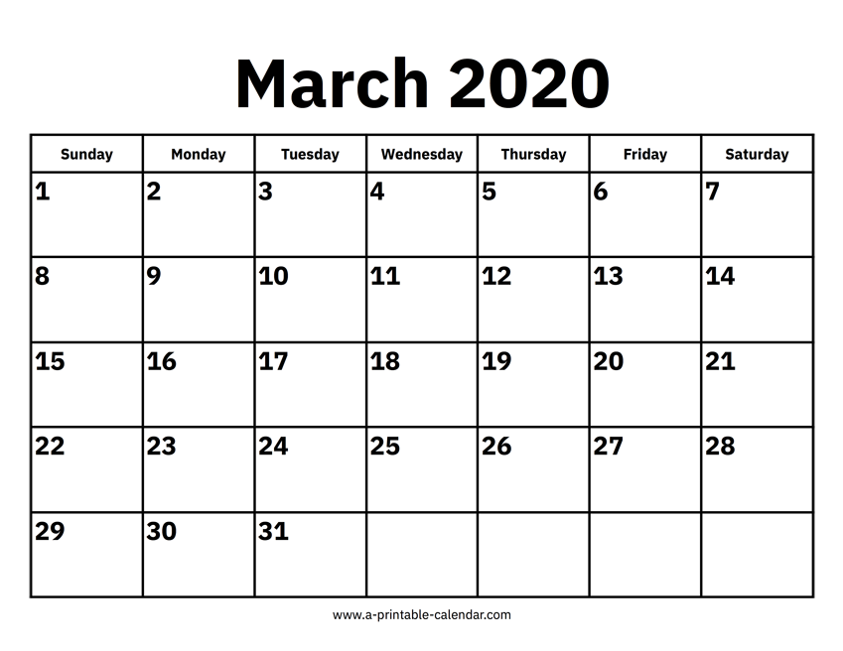

|  |  |  |  |  |  |  |
| --- | --- | --- | --- | --- | --- | --- |
| Sunday | Monday | Tuesday  Recipe Book  Shopping List  Recipe Maker | Wednesday | Thursday | Friday | Saturday |
| 1 | 2 | 3 | 4 | 5 | 6 | 7 |
| 8 | 9 | 10 | 11 | 12 | 13 | 14 |
| 15 | 16 | 17 | 18 | 19 | 20 | 21 |
| 22 | 23 | 24 | 25 | 26 | 27 | 28 |
| 29 | 30 | 31 |  |  |  |  |

Design 2

White Goods

Recipes

Alternate Login

Any Kitchen

Gnocchi

Pancakes

Lasagne

Pad Thai

Banana Bread

Recipes

Alternate Login

White Goods

Any Kitchen

Carrot Cake

Recipes

Alternate Login

White Goods

Any Kitchen

Banana Bread

Ingredients:

-Eggs (4)

-Flour (250g)

Method:

1. Combine all dry ingredients including flour, sugar and cinnamon
2. Mash the bananas into a fine paste

Lasagne

Pad Thai



Shopping List

White Goods

Calendar

Any Kitchen

Search Recipes…

Any Kitchen

Design 3

Banana Bread

Any Kitchen

**Results:**

Delicious Banana Bread

Uploaded by TheCrazyCooker 2/11/19

Basic Banana Bread

Uploaded by HomeChef 13/6/19

**Suggester Recipes:**

Delicious Banana Bread

Lasagne

Gnocchi

Carrot Cake

Banana Bread

Any Kitchen

**White Goods**

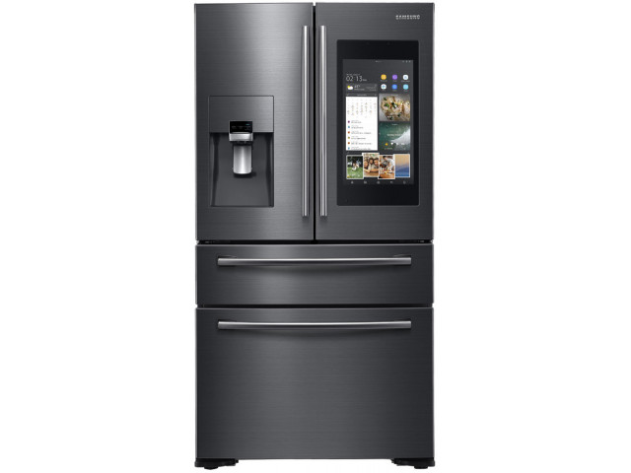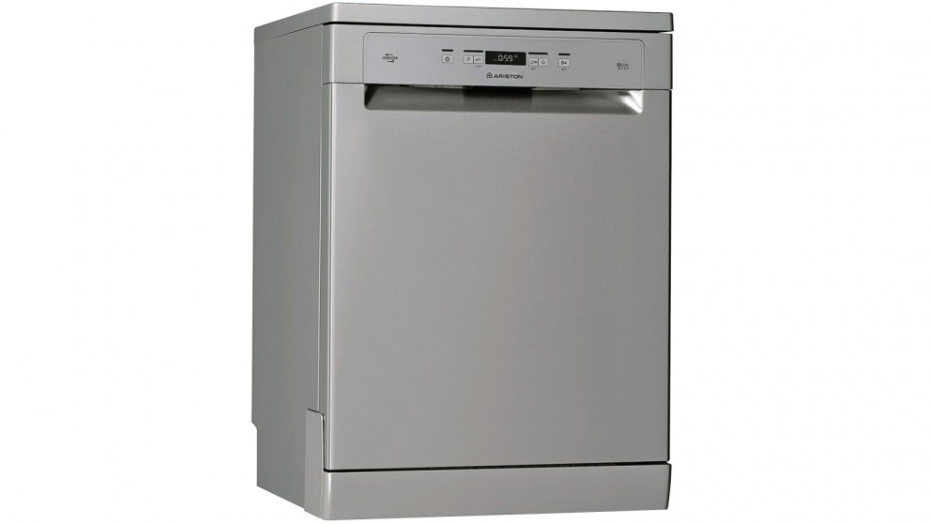

Ariston 60cm Freestanding Dishwasher

Samsung 651L French Door Fridge

Samsung 215L Oven

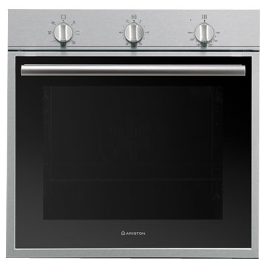

Belvin Convection Cooker

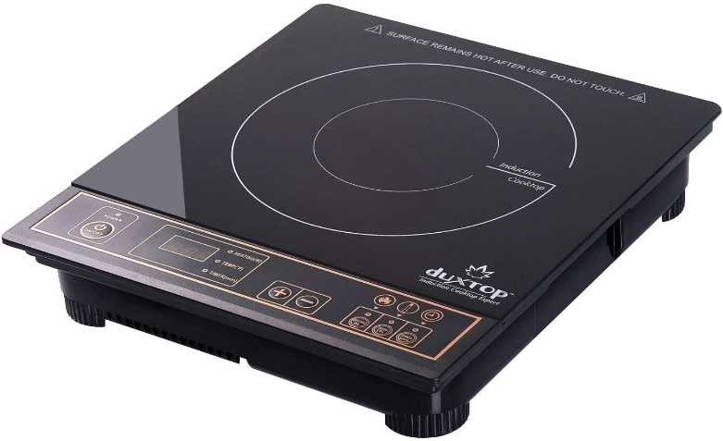

**Design Assessment**

|  |  |  |  |  |  |  |  |
| --- | --- | --- | --- | --- | --- | --- | --- |
|  | **Contrast**  Text and images are easy to see and read | **Creativity**  The design is unique and interesting | **Content**  A balanced amount of content is displayed one each page | **Visual Appeal**  The design is visually appealing in colour and layout | **Simplicity**  The design is simple and would be easy to use and navigate | **Total** | **Average** |
| Design 1 | 5 | 4 | 3 | 5 | 5 | 22 | 4.4 |
| Design 2 | 4 | 2 | 4 | 4 | 5 | 19 | 3.8 |
| Design 3 | 2 | 4 | 1 | 2 | 3 | 13 | 2.6 |

Each design will be graded on a scale from 1-5 on each set of criteria, the score from each criterion for each design will be added together and then divided by 5 to determine the design with the highest overall average

Design 1 had the highest average and had the highest score in the categories Contrast, Visual Appeal and Simplicity. Design 1 had a score of 5 in contrast due to the colour scheme of white text on a red background allowing the text to be visible and legible to the user. It had a score of 4 in creativity as it uses unique design as a whole but came short of achieving a 5 due to it using similar design philosophy to popular apps such as “Paprika” and “Canvas”. Design 1 achieved a lower score then design 2 in content due to less useful content being displayed on each panel then on design 2 which achieved the higher score. In the visual appeal category design, one achieved the highest score with a 5, this is due to the colour scheme being contrasting but also complimentary. It also uses common design philosophy from well-known apps and is therefore familiar. Finally design 1 achieved a score of 5 in simplicity due to the simple layout of the menu options and navigation buttons. Therefore design 1 has been chosen to be the primary design for “Any Kitchen” and will be further developed.

````````````````````````````````````

Delete Button

Any Kitchen

Recipe Book

White Goods

Shopping List

Wishlist

Calendar

Recipe Maker

White Good Provider

Banana Bread

Pancakes

Carrot Cake

Gnocchi

Different Viewing Options

Scroll Bar

Window Options

Pad Thai

Lasagne

Add to Shopping List

Any Kitchen

Recipe Book

White Goods

Shopping List

Wishlist

Calendar

Recipe Maker

White Good Provider

Scroll Indicator

Shopping List Check Box

Back Button

Banana Bread

Ingredients:

-Eggs (4)

-Flour (250g)

-Sugar (100g)

-Bananas (4)

-Cinnamon

Method:

1. Combine all dry ingredients including flour, sugar and cinnamon
2. Mash the bananas into a fine paste

````````````````````````````````````

Any Kitchen

Recipe Book

White Goods

Shopping List

Wishlist

Calendar

Recipe Maker

White Good Provider

Product Image

Samsung 651L French Door Fridge

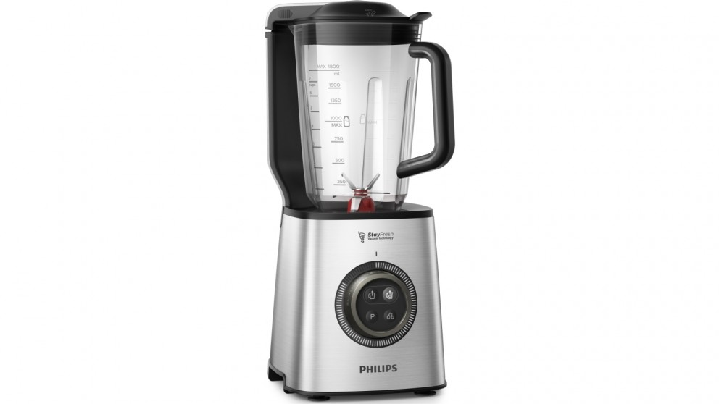

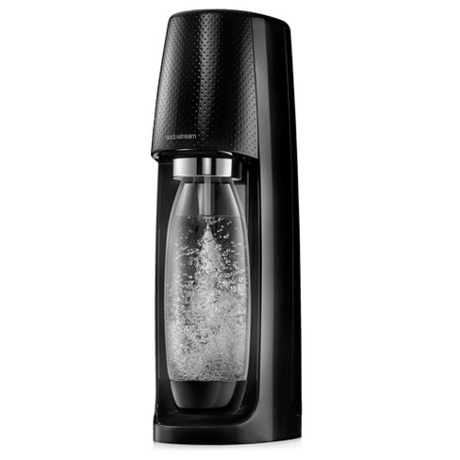

Belvin Convection Cooker



Samsung 651L French Door Fridge







Ariston 60cm Dishwasher

Fridge

Product Description

Add to Wishlist

Any Kitchen

Recipe Book

White Goods

Shopping List

Wishlist

Calendar

Recipe Maker

White Good Provider

Wishlist Check Box

**Samsung 651L French Door Fridge**

**$6,499**



Any Kitchen

Recipe Book

White Goods

Shopping List

Wishlist

Calendar

Recipe Maker

White Good Provider

Edit

Print

Saturday 7th June 2020

Shopping List

-Brown Sugar (480g)

-Flour (1kg)

-Tomatoes (100g)

-Lettuce (2)

-Chicken Steaks (500g)

-Eggs (24)

-SodaStream

Print

Edit

Wishlist

-SodaStream

-Samsung 651L French Door Fridge

-Belvin Convection Cooker

-Ariston 60cm Dishwasher

Any Kitchen

Recipe Book

White Goods

Shopping List

Wishlist

Calendar

Recipe Maker

White Good Provider

Navigation Buttons

Any Kitchen

Recipe Book

White Goods

Shopping List

Wishlist

Calendar

Recipe Maker

White Good Provider

Pancakes

Pad Thai

Banana Bread



User Input Boxes

Any Kitchen

Recipe Book

White Goods

Shopping List

Wishlist

Calendar

Recipe Maker

White Good Provider

e.g. ml, g, kg

Method

Enter Ingredient….

Publish

Amount

Ingredient Name

Enter Recipe Name…..

Any Kitchen

Recipe Book

White Goods

Shopping List

Wishlist

Calendar

Recipe Maker

White Good Provider

Publish

Price:

Description

Upload Image….